201708152125 Visialize MU

I took MUs from probabilistic model and drew them. I was expecting it will show some human body from sticks, but I was wrong

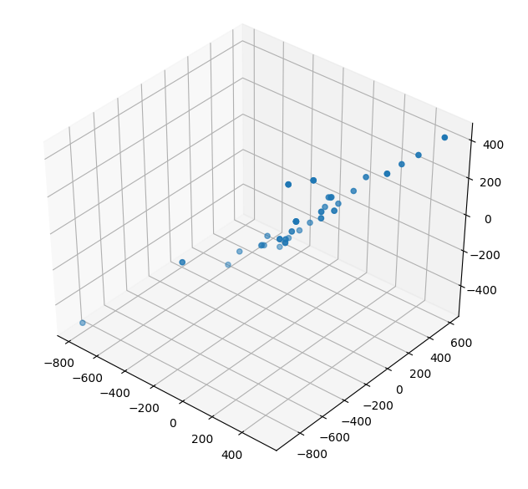
It was a chain of dots presumably linear shape

Script is probab_model_view.py

201708152141
Found transformation to 17 entites in code, but still didn’t get human shape

201708152158
Worked!
